MERIT BADGE BLUE CARD
Instruction Guide

There is only one person who is responsible for your blue card, and that is you.
WHAT IS A BLUE CARD?
The Blue Card is a two-sided, tri-section document, which is formally known as “The Application for Merit Badge”. It is an official Boy Scouts of America document that serves as a record of progress toward completion of a merit badge. You will need to know a few things about this important document if you plan on earning merit badges.

ON YOUR MARK, GET SET, WHOA!
So you want to earn a merit badge. Well in order to record your completed requirements properly you need a Blue Card. You can get these from your Scoutmaster, Committee Chair or Advancement Coordinator. Talk to your Patrol Leader or Senior Patrol Leader and they can direct you to where your Troop keeps their blue cards.

SO NOW THAT I HAVE MY BLUE CARD, HOW DO I FILL IT OUT?

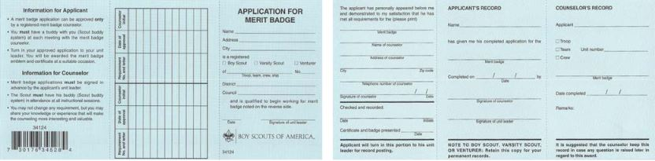Following is a step-by-step guide to completing your Blue Card. Everything you need to know and the steps to follow are outlined in detail on the following pages. Reviewing these and utilizing these instructions will insure that your merit badge paperwork for completion is as accurate and correct as possible. Please keep in mind, it is NOT acceptable for your Scoutmaster, your parent, or anyone besides yourself to fill out YOUR Blue Card. You filling out the Blue Card is just as important as you performing the skills and demonstrating the knowledge in order to complete the requirements for the merit badge. No one else can or should do this for you.

PUTTING PEN TO PAPER
So now that you have your Blue Card, you need to fill it out. Each side of the blue card is divided into three sections, left, center, and right. These three sections should be kept together and not detached from each other until you are finished with the merit badge and instructed to detach a section.

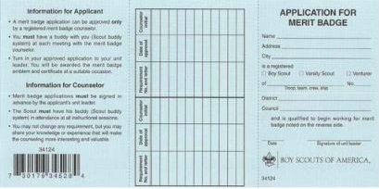
Turn the blue card to what will be referred to as the “front” side and start with the right section of the form. This section requires you to fill in a lot of information.

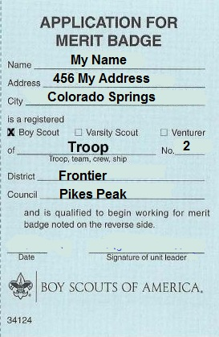
- Start at the top with filling out your full legal name. This means your given first name and last name.
- Next you need to put in your street address followed on the next line with your city, state, and zip code. You may have to write small, but trust me, if you write clearly and small enough, you can fit it all on the two lines.
- Next make sure you check the appropriate box whether you are a Boy Scout, Varsity Scout, or Venturer. The next line you need to fill in whether you are earning this as a member of a Troop, Team, Crew, or Ship, followed by your unit number.
- The following two lines require you to fill in the District in which your unit is associated and the Council in which you belong. If you don’t know your Council, just look at your shoulder patch on your left shoulder for a hint.

Shown above is a sample of what this section should look like when you are finished with this step. We will come back to this side of the Blue Card and this section later.

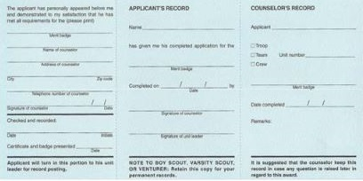
Turn the blue card over and let’s see what needs to be filled out on this side; the “back side”. A good way to look at this is to use the 1-2-3 Method when filling out this side of the Blue Card. Starting from left to right you need to initially fill in 1 item in the left section, 2 items in the center section, and 3 items in the right section. With the 1-2-3 Method, it’s easy as 1-2-3.
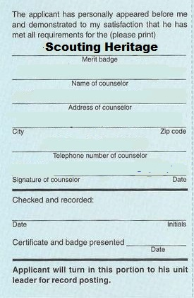

- In the left section on the first line you need to fill in the name of the Merit Badge that this blue card will be for. Just one thing in this section. Don’t worry about the rest of the items in this section at this time. Shown to the right is a sample of what this section should look like when you are finished with this step.

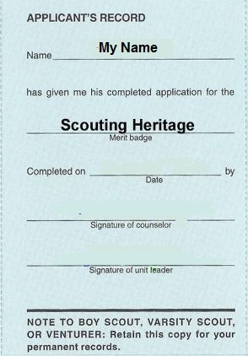
- Now to the center section, there are only two items you need to fill out at this time. The first item is your name, and like on the other side of the blue card, you need to fill out your complete name. The second item in this section is the next line down, which is the Merit Badge that this blue card will be for. Again the other items in this section are to be filled out at a later time, so don’t worry about them now.

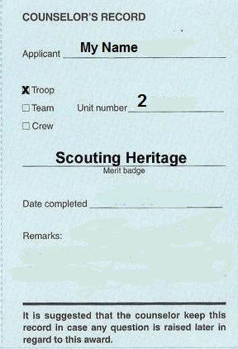

- You are almost done. There are three things to complete on the right section. These three items start with your complete name on the first line. Next check Troop, Team or Crew based on what type of unit you are associated with followed by your unit’s number. Finally, fill in the merit badge that this blue card will be used for on the line labeled, Merit Badge.

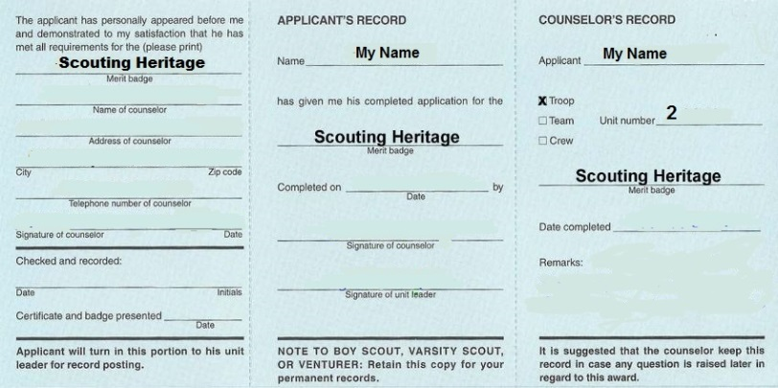

Now Your Card looks like this.

AM I DONE YET? NOT QUITE.

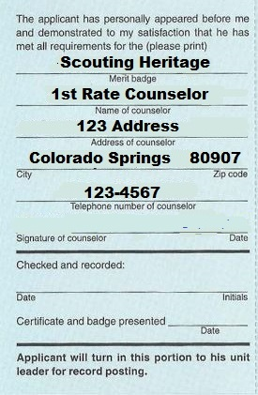
You need to find a Counselor for the merit badge. Check with your Advancement Coordinator to see if an adult in your Troop is registered as a counselor for your Badge. If there isn’t one, he/she can guide you in finding an appropriate Counselor. Fill out your Counselors information on the back of your Card. You may only have you Counselors name at this point.

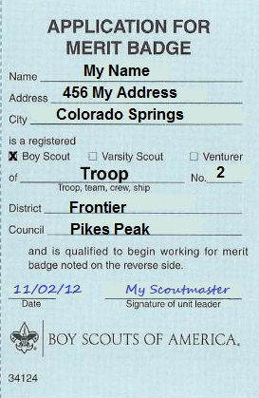
Now you need to take your blue card to your Scoutmaster and get his/her signature on it. This is an important step. Your Scoutmaster’s signature lets him/her know you are working on any merit badge. This process also offers you and your Scoutmaster the opportunity to discuss any questions or concerns either of you might have regarding your commitment to working towards completing this merit badge. Your Scoutmaster may also share concerns or challenges he/she might know of or foresee that you may need to be aware of. Finally, your Scoutmaster’s signature serves as a means of helping your merit badge counselor know that you are a currently registered Scout in a properly registered unit.

Make sure you know where your Scoutmaster needs to sign the blue card. Turn to the front side where you filled out all of your information at first in the right section. Near the bottom of this section your Scoutmaster will date and sign your blue card.

HOW DO YOU START WORKING ON YOUR MERIT BADGE?
Be sure that before you start working on ANY merit badge, you to get the current requirements at meritbadge.org or the current merit badge pamphlet for the merit badge you are working on. Your local Scout Shop has these for sale but you may also want to check with your Troop Librarian to see if your unit might have a copy in the unit library that you could use.

It is good to read the merit badge pamphlet when working on ANY merit badge. As you go thru the merit badge pamphlet, you will find that most of the requirements are thoroughly explained with the contents of the merit badge pamphlet. Often times Scouts find it helpful to use the Merit Badge Worksheets to help take notes and mark down their findings and accomplishments for the requirements of the merit badge they are working on. You can download these off of meritbadge.org.

TIME TO MEET THE MERIT BADGE COUNSELOR.
Once you have reviewed the Merit Badge Pamphlet or Worksheet and made your notes, you can assess what you have completed and ready yourself to meet with your merit badge counselor. Remember, it is always best to be ready to show your merit badge counselor what you have done when you first meet with him or her. During this meeting you may find that you have completed some of the requirement with your preparation work. Your merit badge counselor will help direct you to other people or resources that might assist you in completing unfinished requirements
.
COMPLETION OF REQUIREMENTS = INITIALS AND DATES
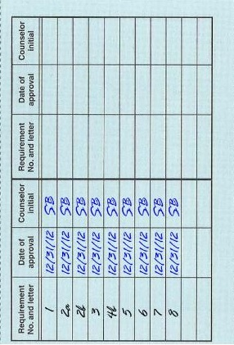
Your merit badge counselor will help direct you to other people or resources that might assist you in completing unfinished requirements. Not only do you need to know what needs to be filled in by yourself, you should also know and understand what your Merit Badge Counselor needs to be responsible for. Ultimately it is YOUR responsibility to make sure that your Blue Card is filled out correctly and completely. Remember a Scout is kind and courteous, so if you find that your merit badge counselor appears to have omitted something or not completed something properly, you can, and should, politely inquiry for clarification.

When you have completed a requirement to the satisfaction of your merit badge counselor, your counselor will sign off that you have completed the requirements by marking off on the middle section of the front side of the Blue Card.
You or your counselor may write down the requirement numbers and letters in the first column in this section for the specific merit badge. Your merit badge counselor will then date and initial those requirements that you complete.

It is YOUR responsibility to make sure that your merit badge counselor completes this area completely and correctly. After you have finished and been signed off on all your requirements, this back center section should have all the requirements for the merit badge listed with your counselors initials and dated. You may have worked with multiple counselors on this merit badge, but you need to do a few things with the counselor that signs you off on your final requirement.

YOU STILL NEED A FEW AUTOGRAPHS
Now that all of your requirements have been initialed and dated, there are a couple of areas that need to be filled out to complete the earning of this merit badge.
Turn your blue card over to the front side and let’s start in the left section. Here you will need to make sure to fill out the contact information of your merit badge counselor. (Some merit badge counselors will do this for you) Remember it is your responsibility to make sure this is done correctly. Fill out the counselor’s name, street address, city, state, and zip code along with the counselor’s telephone number.

This section should only contain the Counselor Information for the Merit Badge Counselor that is providing final sign off on the merit badge. Many Scouters believe that a Boy Scout must finish a merit badge with the same counselor they start it with. This is untrue. If Scouts are using a Counselor the Troop does not know they should maintain contact information for those counselors that they have worked with on the merit badge.

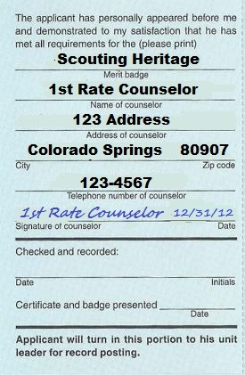
If a Scout is signed off on a requirement by one merit badge counselor, another merit badge counselor cannot retest or revoke the signed off requirement. However, if previous counselor contact information can not be validated, the merit badge counselor being asked to do the final sign off can review those requirements with the Scout. Once the counselor is ready to sign off completion of the merit badge, the counselor’s signature is required on this left section along with the date of completion. It is YOUR responsibility to make sure that your merit badge counselor signs and dates this section clearly and correctly. In the center section the merit badge counselor will need to enter the completion date and also sign off in this section as well.
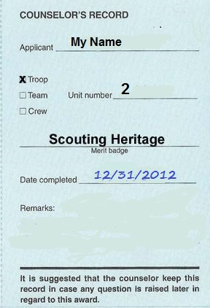
Finally on the right section your counselor will fill in the completion date and make any special notes in the Remarks section.

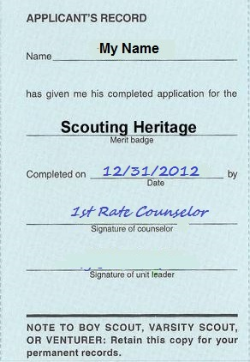
You have now finished your merit badge, but you aren’t finished with your blue card. Make sure your Merit badge counselor removes the right section of the card – labeled Counselor’s Record at the top, for his or her records. You should get two of the three sections back and make sure you keep them connected.

In the center section the merit badge counselor will need to enter the completion date and also sign off in this section as well.

YOU’RE ALMOST DONE
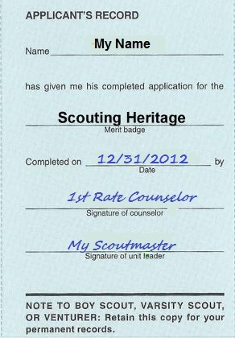
When you return to your next unit meeting, you will need to get you Scoutmasters signature on the Applicants Record section of your Blue Card. Then turn in the “The Application for Merit Badge” section of your blue card to your Troops Advancement Coordinator to show that you have completed your merit badge. Your unit’s Advancement Coordinator will then process your Merit Badge Application and short you will be awarded your merit badge at the next Court of Honor.

RECORD KEEPING
You will need to keep the center section of your blue card in a very safe place, do NOT throw it away. It is recommended you keep these in the plastic baseball card sections in your Troop notebook. When you go to your Eagle Board of Review you will need to bring all your blue cards with you to show the review board all of the merit badges you have completed.

Working on merit badges will cover a period of a number of years so it is important that you keep your blue cards in one, safe, organized location. Keep them safe and together.

CONGRATULATIONS you have successfully completed your merit badge.

Revised 6/2/2015

ENLARGED SAMPLE OF COMPLETED BLUE CARD

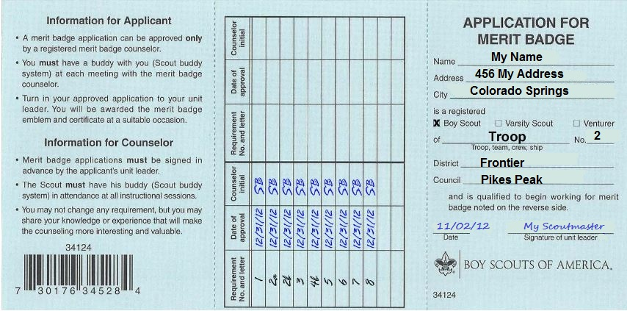
Front of Blue Card

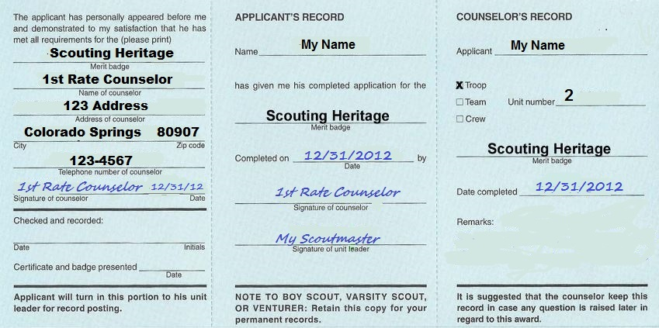
Back of Blue Card

